Curriculum Vitae
Amany Hassan Abd El Wahab

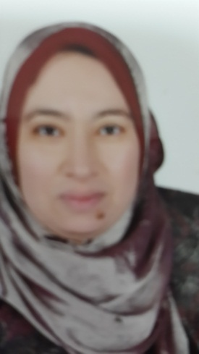
PERSONAL INFORMATION:
• Name: Amany Hassan Abd El Wahab.
• Sex: female.
• Date of birth: 1/11/1976.
• Place of birth: Assiut,Egypt.
• Nationality: Egyptian.
• Marital state: Married.

For Correspondence:
• Address: Department of Anesthesiology and Intensive Care and Pain Management, Assiut University Teaching Hospital, Assiut, Postal Code 71111, Egypt.
• E-mail:amanihassan1976@yahoo.com
• Phone: Home: +20-88-2353434.
Mobile: +20-1004610623.
• Current Position: Lecturer, Department of Anesthesiology and Intensive Care and Pain Management , Assiut University Hospital, Assiut, Egypt.

QUALIFICATIONS:
- doctoral degree in Anesthesia, ICU, and Pain management signed up with "Very Good" studying anatomy, physiology, pharmacology , biochemistry, principles of oncology, supportive care for cancer patients, biostatistics, and pain measurement(2014).
- M.Sc. in anesthesia and postoperative ICU " Good", (2005)
Title of the thiese is " Intrathecal morphine versus nalbuphine for postoperative pain relief in patients undergoing lower limb orthopedic surrgery " , Faculty of medicine, Assiut University.
-First part of master degree in Anesthesia ,ICU, and pain management signed up with "Very Good" studying anatomy, physiology, pharmacology ,physics)2002).
- M.B.B.Ch. of Medicine and General Surgery "(2005) Faculty of medicine, Assiut University.
TRAINING POSTS:
-April 2014-present: Lecturer
- March 2006– March 2014: Assistant Lecturer.
- March 2002– Feb. 2005: anesthesiology and intensive care unit Resident:
In the department of Anesthesiology and Intensive Care and Pain Management , Assiut University Teaching Hospital, (The largest tertiary medical center in Upper Egypt).

CONFERENCES:
-4th -7th December,2012: Attendence of the 6th Assiut Anesthesia conference. sunrise , Hurghada , Egypt.
-2nd-6th December,2013:Attendence of the 7th Assiut Anesthesia conference. Tia hieghts , Hurghada , Egypt.
LANGUAGES EXPERIENCE:
- Arabic .
- English.
- German:2 studying years (secondary school second language course).

LEISURE ACTIVITIES:
- Reading and listening to classic music.
- Playing soccer and table tennis.
- Traveling and site seeing.
- Watching movies.

